Vulcan Activity Tracker
Weekly Report

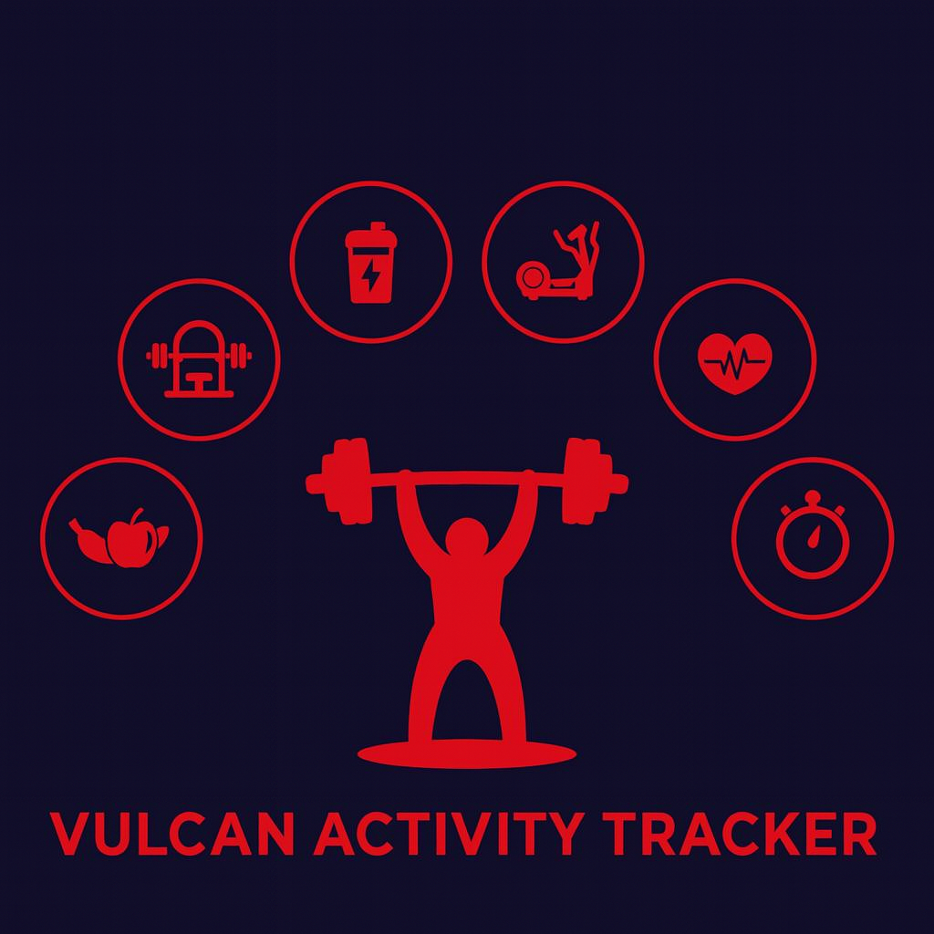

Week 4
Team Members:
Margo Bonal
John Gerega
Luke Ruffing

Professor:
Dr. Weifeng Chen

Course: CMSC-4920-Senior Project II
School: Pennsylvania Western University

Project: Vulcan Activity Tracker
To complete the proposed goals in previous week’s report, our team followed a strict schedule of daily progress and communication. Our team had 4 main goals to complete, leaderboard page set up, club page set up, continuing progress on the dashboard, and improvements to data filtering and validation. Since each goal needed time allocation for development and testing, we assigned each goal priority based on how they were connected to each other. Throughout the discussion, we decided that leaderboard and club page creation was the number one priority to accomplish at the start of the week. This is because the program is now able to accept user data, which we would now like to display on a leaderboard. Creation of the club page is an important first step in the community aspect we would like to create within the program. Creation of database schema and API architecture was included in this priority to make the feature fully work.
Goals Accomplished:
One of the most important goals for this week was the setup of the leaderboard page. The leaderboard page is designed to extract users’ activities and filter them based on activity type or other general statistics. A new API endpoint was created to extract all public activity data users submit to the database. This allows public activity data to be pulled from the database and filtered based on the selected filter. Although the leaderboard page is still unfinished, the progress made this week defines the flow of data from the database to the leaderboard.
Another goal this week was the initial development and setup of the Club page. The Club page frontend is set up with two main lists on the page. One holds the clubs the current user owns or is a member of and the second list holds all the clubs the user is not a member or owner of. Along with the two lists there is a form a user can fill out to add make their own club, currently the form only asks for a name and description of the club before allowing creation of the club. A new schema was designed to create a table in the database to hold individual club data like: Club ID, Club Name, Description, Club Creator ID, Members, Created Date, Updated date.
Our third goal of this week was to continue the development of the dashboard page of the activity tracker. During this week our efforts to work on the dashboard have proven successful, as the dashboard is now able to display user activity data as a clean list. Activities are stored upon creation on the designated Training page. They are prepared and normalized for database entry. Activities are stored in the database during this process. A secondary API serves as a fetch to the database simultaneously. It first displays that there are no activities added on the dashboard prior to activity creation. When an activity is successfully stored, this API will then fetch the user’s specific activity by cross referencing the user’s unique ID to prevent another user’s data from being displayed. This activity data is then formatted to be user friendly, by displaying activities in order of newest created and changing date from database format to user readable. Activities are displayed as dynamic cards on the dashboard to allow for interactable components. They are styled to match the cohesive overall design of the platform. The activity data being successfully displayed represents the first of many improvements to the dashboard.
An additional dashboard improvement was achieved during this week’s development. This was the creation of the Friends feature. It was not previously proposed as a goal but was pivotal to be developed early in our timeline to allow for continuous development. The friend’s feature is incorporated on the dashboard. It allows a user to browse the current registered student users of the Vulcan Activity Tracker. It allows you to select that user by their username and add them to the Friends card. Friends are then stored into the database with a cross reference to the user that added them so platform account will not show conflicting or cross information. Once a friend is added, that username is removed from the available new friends list. Additionally, users are not allowed to add themselves as a friend. Challenges that were presented during the creation feature will be discussed further below.
Challenges Faced: (Number aligns with its solution below)
1. The activity table had residual timing issues from previous week’s development. When an activity form was filled with data and submitted, the viewing table was not immediately refreshed to show this update. The page had to be manually refreshed to show this change. This API timing error broke the user illusion of continuous functionality. Async JavaScript functions must be paired with an await to signal the waiting for data to cross the API, however this await can sometimes not return in proper time due to logic errors.
2. A challenge that arose while building the club page was a flaw in the logic that adds members to a club, the flaw allowed the creator of the club to join their own club as a normal member. This could lead to duplicate memberships and permission issues within the club.
3. Leaderboard filtering presented many challenges during this week’s development. Since a user’s activity data is quite complex due to common and specific fields per sport type, filtering and displaying this data brought challenges. The Vulcan Activity Tracker’s leaderboard feature not only processes a singular user at a time but also calculates and processes all users of the platform. This data handling proves complex in sorting unique user IDs to maintain organization. The leaderboard feature does not currently have a solution, since it requires further development. Solutions will be included in upcoming weekly reports to track continued leaderboard progress.
4. Friend Dashboard feature had a few challenges during development. These mostly can be categorized as server-side challenges with database logic. A user should not be allowed to add themselves as a Friend. Also, once a friend is added to the list, they must be removed from the list to eliminate duplicate friend errors. It was tricky to plan this logic since the platform is designed for multiple users, friends had to be logged per user so for example user1 can only see his friends on his dashboard and user 2 can’t see user1 friends. This separation proved to be challenging.
Solutions:
1. Activity table submission logic was corrected by carefully tracing API timing paths. Many console logs were placed to follow the data sent through the code. Once identified where the data was being caught, a solution could be made. The activity table needs to be triggered twice, once when data is submitted and second when the page is loaded. Each fillActivityTable(username) function is paired with an await statement to halt processing until data is completely sent. Now when a student user fills out the table and clicks submit, the API is triggered to collect the data, send to backend where it is stored in the database, and then sent back to the frontend to be prepared/ displayed in the table. The second fill activity command runs when a user, for example, changes pages then returns to the Training Page. This second API fills the table immediately with the stored activity data so the user can always view progress.
2.To fix this issue we implemented a specific column in the clubs schema that holds the creator’s user id and added a conditional verification to make sure the owner cannot join their own club. We also removed clubs owned by a user from the joinable club list so they cannot even attempt to join them.
4. The following solutions completed the addition of Friends Feature for this week’s development. A database table was created strictly for Friends. Here, friends can be cross referenced with the user’s unique ID that added them. A list can be stored of saved friends/ existing friends, and also users that are still available to be added as a friend. Filtering is processed on the client side of the application to not allow a user to add themselves or a friend that already exists in their friend list.
Team Progress:
According to our Group 2 Gantt chart, our team is ahead of schedule for many parts of the tracker, this can be attributed to having more time and less assignments in the early weeks of the semester. However, we are still exactly on schedule for dashboard development. During this week our core focus has shifted to the leaderboard and club pages. Significant progress had been made on the club page, including the initial frontend layout, development of the API endpoints, and the creation of the clubs database schema. Leaderboard page is also progressing far ahead of schedule. With the initial frontend design completed, we were able to focus on developing the API endpoint to pull activity data from the database and then prepare it for filtering and ranking. The dashboard development of this week remained right on schedule and had successful progress. While the clubs, leaderboards, and dashboard pages are still under development steps taken this week have given the pages a strong foundation to keep building on.

Gantt Chart:
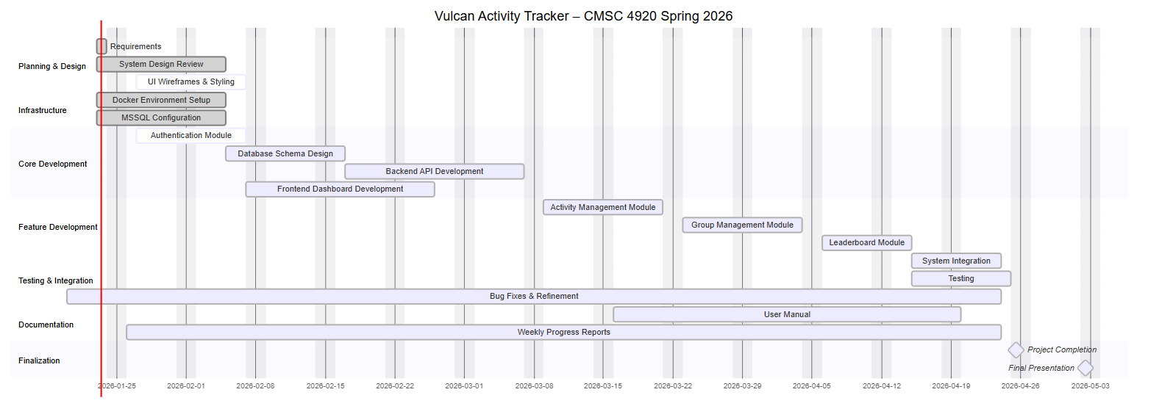

Week 4 Plan:
Durning week 4 our team plans to continue development on the features and pages worked on this week while also starting development on some new features. With the initial design and some of the basic features being completed within the clubs and leaderboard pages, one of this week’s goals is to further expand on that progress. This includes improving data filtering and ranking within the leaderboard page and adding more features to the club page.
In addition to working on existing features the team will begin initial development of some social components of the tracker. This includes planning and maybe perhaps early implementation of group challenges and friend-related features. We propose that week 4 will be a productive week to move our project a step closer to the end goal!

Member Contribution:
Margo Bonal:
- Team meetings, Week 4 Report & Slides, Dashboard page progress, Activities displayed on dashboard, Addition of Friends feature, Schema/ API creation, Docker performance upgrades, Project Screen Recording
John Gerega:
- Team meetings, Week 4 Report & Slides, Leaderboard page progress
Luke Ruffing:
- Team meeting, Week 4 Report & Slides, Clubs page progress

